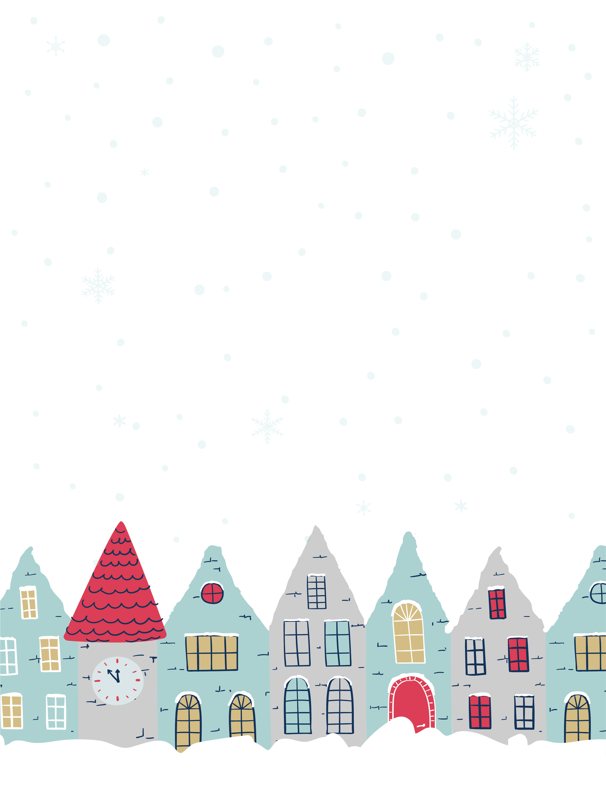
Surprise visit from SANTA!!

